Design and analysis of algorithm
Lecture notes

Introduction
Definition
- An algorithm is a sequence of unambiguous instructions for solving a problem, i.e., for obtaining a required output for any legitimate input in a finite amount of time.
- An algorithm is a set of steps of operations to solve a problem performing calculation, data processing, and automated reasoning tasks.
- An algorithm is an efficient method that can be expressed within finite amount of time and space.
- An algorithm is the best way to represent the solution of a particular problem in a very simple and efficient way. If we have an algorithm for a specific problem, then we can implement it in any programming language, meaning that the algorithm is independent from any programming languages.
features of an algorithm?
- More precisely, an algorithm is a method or process to solve a problem satisfying the following properties:
  - Finiteness
    - terminates after a finite number of steps
  - Definiteness
    - Each step must be rigorously and unambiguously specified.
-e.g., ”stir until lumpy”
  - Input
    - Valid inputs must be clearly specified.
  - Output
    - can be proved to produce the correct output given a valid can be proved to produce the correct output given a valid input.
  - Effectiveness
    - Steps must be sufficiently simple and basic.

The notion of an algorithm.
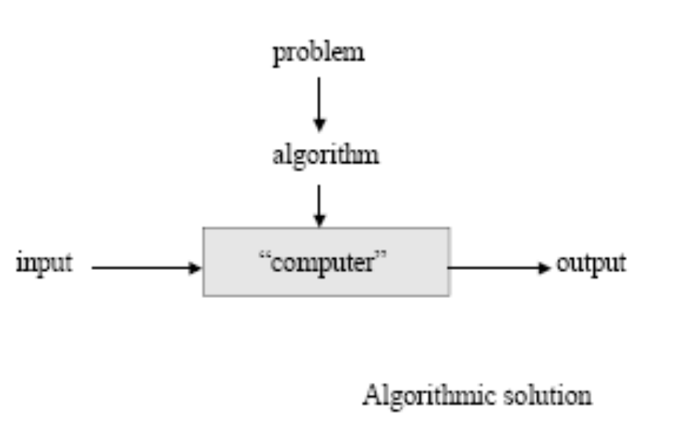

The Different type’s problem
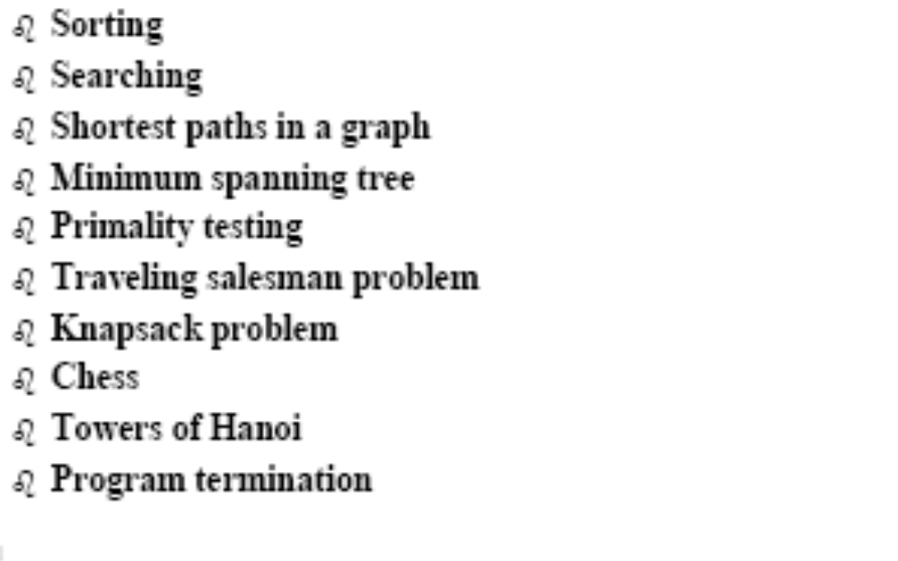

6) What are fundamental data structures?

- list
  - array
  - linked list
  - string
- stack
- queue
- priority queue
- graph
- tree
- set and dictionary

Algorithm Design
The different algorithm design techniques/strategies?
- Brute force
- Divide and conquer
- Decrease and conquer
- Transform and conquer
- Space and time tradeoffs
- Greedy approach
- Dynamic programming
- Backtracking Branch and bound
The important aspects of algorithm design include
- creating an efficient algorithm to solve a problem in an efficient way using minimum time and space.
- To solve a problem, different approaches can be followed. Some of them can be efficient with respect to time consumption, whereas other approaches may be memory efficient. However, one has to keep in mind that both time consumption and memory usage cannot be optimized simultaneously. If we require an algorithm to run in lesser time, we have to invest in more memory and if we require an algorithm to run with lesser memory, we need to have more time.

Pseudocode
Pseudocode gives a high-level description of an algorithm without the ambiguity associated with plain text but also without the need to know the syntax of a particular programming language.
The running time can be estimated in a more general manner by using Pseudocode to represent the algorithm as a set of fundamental operations which can then be counted.

Difference between Algorithm and Pseudocode
An algorithm is a formal definition with some specific characteristics that describes a process, which could be executed by a Turing-complete computer machine to perform a specific task. Generally, the word "algorithm" can be used to describe any high level task in computer science.
On the other hand, pseudocode is an informal and (often rudimentary) human readable description of an algorithm leaving many granular details of it. Writing a pseudocode has no restriction of styles and its only objective is to describe the high level steps of algorithm in a much realistic manner in natural language.
Example
Algorithm: Insertion-Sort
Input: A list L of integers of length n
Output: A sorted list L1 containing those integers present in L
Step 1: Keep a sorted list L1 which starts off empty
Step 2: Perform Step 3 for each element in the original list L
Step 3: Insert it into the correct position in the sorted list L1.
Step 4: Return the sorted list
Step 5: Stop

A pseudocode which describes how the high level abstract process mentioned above in the algorithm Insertion-Sort could be described in a more realistic way.

for i <- 1 to length(A)
x <- A[i]
j <- i
while j > 0 and A[j-1] > x
A[j] <- A[j-1]
j <- j - 1
A[j] <- x
Fundamentals of Algorithmic Problem Solving
- Understanding the problem
  - Asking questions, do a few examples by hand, think about special cases, etc.
- Deciding on
  - Exact vs. approximate problem solving
  - Appropriate data structure
- Design an algorithm
- Proving correctness
- Analyzing an algorithm
  - Time efficiency : how fast the algorithm runs
  - Space efficiency: how much extra memory the algorithm needs.
- Coding an algorithm

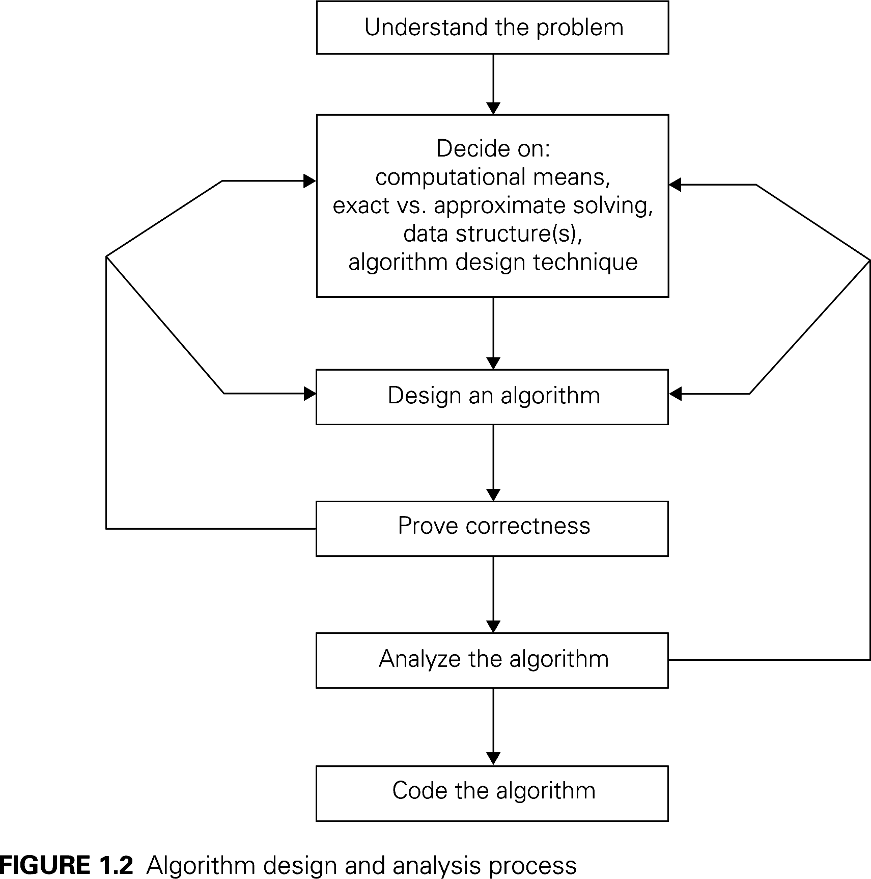
analysis algorithm
In theoretical analysis of algorithms, it is common to estimate their complexity in the asymptotic sense, i.e., to estimate the complexity function for arbitrarily large input. The term "analysis of algorithms" was coined by Donald Knuth.
Algorithm analysis is an important part of computational complexity theory, which provides theoretical estimation for the required resources of an algorithm to solve a specific computational problem. Most algorithms are designed to work with inputs of arbitrary length. Analysis of algorithms is the determination of the amount of time and space resources required to execute it.
Usually, the efficiency or running time of an algorithm is stated as a function relating the input length to the number of steps, known as time complexity, or volume of memory, known as space complexity.

The Need for Analysis
In this chapter, we will discuss the need for analysis of algorithms and how to choose a better algorithm for a particular problem as one computational problem can be solved by different algorithms.
By considering an algorithm for a specific problem, we can begin to develop pattern recognition so that similar types of problems can be solved by the help of this algorithm.
Algorithms are often quite different from one another, though the objective of these algorithms are the same. For example, we know that a set of numbers can be sorted using different algorithms. Number of comparisons performed by one algorithm may vary with others for the same input. Hence, time complexity of those algorithms may differ. At the same time, we need to calculate the memory space required by each algorithm.
Analysis of algorithm is the process of analyzing the problem-solving capability of the algorithm in terms of the time and size required (the size of memory for storage while implementation). However, the main concern of analysis of algorithms is the required time or performance. Generally, we perform the following types of analysis −
- Worst-case − The maximum number of steps taken on any instance of size a.
  - Efficiency (# of times the basic operation will be executed) for the worst case input of size n.
  - The algorithm runs the longest among all possible inputs of size n.
- Best-case − The minimum number of steps taken on any instance of size a.
  - Efficiency (# of times the basic operation will be executed) for the best case input of size n.
  - The algorithm runs the fastest among all possible inputs of size n.
- Average case − An average number of steps taken on any instance of size a.
  - Efficiency (#of times the basic operation will be executed) for a typical/random input of size n.
  - NOT the average of worst and best case
  - How to find the average case efficiency?
- Amortized − A sequence of operations applied to the input of size a averaged over time.
To solve a problem, we need to consider time as well as space complexity as the program may run on a system where memory is limited but adequate space is available or may be vice-versa. In this context, if we compare bubble sort and merge sort. Bubble sort does not require additional memory, but merge sort requires additional space. Though time complexity of bubble sort is higher compared to merge sort, we may need to apply bubble sort if the program needs to run in an environment, where memory is very limited.
Algorithm analysis framework
Analysis of algorithms means to investigate an algorithm’s efficiency with respect to resources: running time and memory space
Time efficiency: how fast an algorithm runs.
Space efficiency: the space an algorithm requires.
- Typically, algorithms run longer as the size of its input increases
- We are interested in how efficiency scales wrt input size
Analysis Framework
- Measuring an input’s size
- Measuring running time
- Orders of growth (of the algorithm’s efficiency function)
- Worst-base, best-case and average-case efficiency
How the running time of an algorithm is measured?
Units for Measuring Running Time
- Count the number of times an algorithm’s basic operation is executed.
  - Basic operation: the operation that contributes the most to the total running time.
  - For example, the basic operation is usually the most time-consuming operation in the algorithm’s innermost loop.
Time effieciency is analysed
- Time efficiency is analyzed by determining the number of repetitions of the basic operation as a function of input size.
running time
execution time
for the basic operation
Number of times the basic operation is executed
input size
T(n) ≈ c_{op}C (n)

Methodology of Analysis
To measure resource consumption of an algorithm, different strategies are used as discussed in this chapter.

Asymptotic Analysis
The asymptotic behavior of a function f(n) refers to the growth of f(n) as n gets large.
We typically ignore small values of n, since we are usually interested in estimating how slow the program will be on large inputs.
A good rule of thumb is that the slower the asymptotic growth rate, the better the algorithm. Though it’s not always true.
For example, a linear algorithm f(n)=d∗n+k is always asymptotically better than a quadratic one, f(n)=c.n²+q
.

Solving Recurrence Equations
A recurrence is an equation or inequality that describes a function in terms of its value on smaller inputs. Recurrences are generally used in divide-and-conquer paradigm.
Let us consider T(n) to be the running time on a problem of size n.
If the problem size is small enough, say n < c where c is a constant, the straightforward solution takes constant time, which is written as θ(1). If the division of the problem yields a number of sub-problems with size nb
.To solve the problem, the required time is a.T(n/b). If we consider the time required for division is D(n) and the time required for combining the results of sub-problems is C(n), the recurrence relation can be represented as −
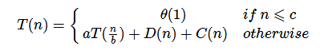
A recurrence relation can be solved using the following methods −
- Substitution Method − In this method, we guess a bound and using mathematical induction we prove that our assumption was correct.
- Recursion Tree Method − In this method, a recurrence tree is formed where each node represents the cost.
- Master’s Theorem − This is another important technique to find the complexity of a recurrence relation.

Amortized Analysis
Amortized analysis is generally used for certain algorithms where a sequence of similar operations are performed.
- Amortized analysis provides a bound on the actual cost of the entire sequence, instead of bounding the cost of sequence of operations separately.
- Amortized analysis differs from average-case analysis; probability is not involved in amortized analysis. Amortized analysis guarantees the average performance of each operation in the worst case.
It is not just a tool for analysis, it’s a way of thinking about the design, since designing and analysis are closely related.

Asymptotic Notations
In designing of Algorithm, complexity analysis of an algorithm is an essential aspect. Mainly, algorithmic complexity is concerned about its performance, how fast or slow it works.
The complexity of an algorithm describes the efficiency of the algorithm in terms of the amount of the memory required to process the data and the processing time.
Complexity of an algorithm is analyzed in two perspectives: Time and Space.

Time Complexity
It’s a function describing the amount of time required to run an algorithm in terms of the size of the input. "Time" can mean the number of memory accesses performed, the number of comparisons between integers, the number of times some inner loop is executed, or some other natural unit related to the amount of real time the algorithm will take.

Space Complexity
It’s a function describing the amount of memory an algorithm takes in terms of the size of input to the algorithm. We often speak of "extra" memory needed, not counting the memory needed to store the input itself. Again, we use natural (but fixed-length) units to measure this.
Space complexity is sometimes ignored because the space used is minimal and/or obvious, however sometimes it becomes as important an issue as time.

Asymptotic Notations
Execution time of an algorithm depends on the instruction set, processor speed, disk I/O speed, etc. Hence, we estimate the efficiency of an algorithm asymptotically.
Time function of an algorithm is represented by T(n), where n is the input size.
Different types of asymptotic notations are used to represent the complexity of an algorithm. Following asymptotic notations are used to calculate the running time complexity of an algorithm.
- O − Big Oh
- Ω − Big omega
- θ − Big theta
- o − Little Oh
- ω − Little omega

O: Asymptotic Upper Bound
‘O’ (Big Oh) is the most commonly used notation. A function f(n) can be represented is the order of g(n) that is O(g(n)), if there exists a value of positive integer n as n₀ and a positive constant c such that −
f(n)⩽c.g(n) for n>n0 in all case
Hence, function g(n) is an upper bound for function f(n), as g(n) grows faster than f(n).

Example
Let us consider a given function, f(n)=4.n³+10.n²+5.n+1
Considering g(n)=n³,
f(n)⩽5.g(n) for all the values of n>2
Hence, the complexity of f(n) can be represented as O(g(n)) , i.e. O(n³)
- Formal definition
  - A function t(n) is said to be in O(g(n)), denoted t(n) ∈O(g(n)), if t(n) is bounded above by some constant multiple of g(n) for all large n, i.e., if there exist some positive constant c and some nonnegative integer n0 such that
t(n) ≤ cg(n) for all n ≥ n0
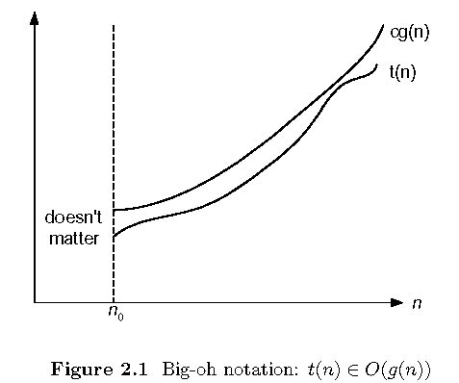
  - O(g(n)): class of functions f(n) that grow no faster than g(n)

Ω: Asymptotic Lower Bound
We say that f(n)=Ω(g(n)) when there exists constant c that f(n)⩾c.g(n) for all sufficiently large value of n. Here n is a positive integer. It means function g is a lower bound for function f; after a certain value of n, f will never go below g.

Example
Let us consider a given function, f(n)=4.n3+10.n2+5.n+1
.considering g(n)=n3 , f(n)⩾4.g(n) for all the values of n>0
.Hence, the complexity of f(n) can be represented as Ω(g(n)), i.e. Ω(n³)

- Formal definition
  - A function t(n) is said to be in Ω(g(n)), denoted t(n) ∈ Ω(g(n)), if t(n) is bounded below by some constant multiple of g(n) for all large n, i.e., if there exist some positive constant c and some nonnegative integer n0 such that
t(n) ≥ cg(n) for all n ≥ n0

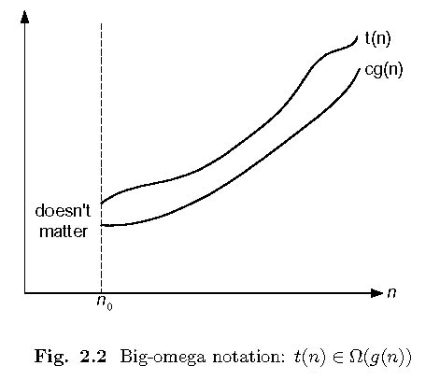
  - Ω(g(n)): class of functions f(n) that grow at least as fast as g(n)

θ: Asymptotic Tight Bound
We say that f(n)=θ(g(n)) when there exist constants c₁ and c₂ that c₁.g(n)⩽f(n)⩽c₂.g(n) for all sufficiently large value of n. Here n is a positive integer.
This means function g is a tight bound for function f.

Example
Let us consider a given function, f(n)=4.n3+10.n2+5.n+1
Considering g(n)=n³, 4.g(n)⩽f(n)⩽5.g(n) for all the large values of n.
Hence, the complexity of f(n) can be represented as θ(g(n)) , i.e. θ(n³)
- Formal definition
  - A function t(n) is said to be in Θ(g(n)), denoted t(n) ∈ Θ(g(n)), if t(n) is bounded both above and below by some positive constant multiples of g(n) for all large n, i.e., if there exist some positive constant c1 and c2 and some nonnegative integer n0 such that
c2 g(n) ≤ t(n) ≤ c1 g(n) for all n ≥ n0

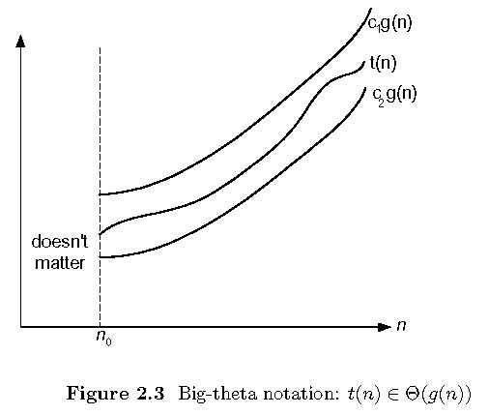

  - Θ (g(n)): class of functions f(n) that grow at same rate as g(n)

.O - Notation
The asymptotic upper bound provided by O-notation may or may not be asymptotically tight. The bound 2.n²=O(n²) is asymptotically tight, but the bound 2.n=O(n²) is not.
We use o-notation to denote an upper bound that is not asymptotically tight.
We formally define o(g(n)) (little-oh of g of n) as the set f(n) = o(g(n)) for any positive constant c>0 and there exists a value n0>0, such that 0⩽f(n)⩽c.g(n)
.Intuitively, in the o-notation, the function f(n) becomes insignificant relative to g(n) as n approaches infinity; that is,

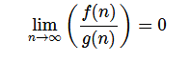

Example
Let us consider the same function, f(n)=4.n³+10.n²+5.n+1
Considering g(n)=n⁴,
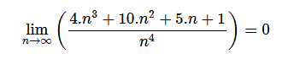
Hence, the complexity of f(n) can be represented as o(g(n)) , i.e. o(n⁴)
.

ω – Notation
We use ω-notation to denote a lower bound that is not asymptotically tight. Formally, however, we define ω(g(n)) (little-omega of g of n) as the set f(n) = ω(g(n)) for any positive constant C > 0 and there exists a value n0>0
, such that 0⩽c.g(n)<f(n)
.
For example, n22=ω(n)
, but n22≠ω(n2). The relation f(n)=ω(g(n))
implies that the following limit exists
limn→∞(f(n)g(n))=∞
That is, f(n) becomes arbitrarily large relative to g(n) as n approaches infinity.

Example
Let us consider same function, f(n)=4.n3+10.n2+5.n+1
Considering g(n)=n2
,
limn→∞(4.n3+10.n2+5.n+1n2)=∞
Hence, the complexity of f(n) can be represented as o(g(n))
, i.e. ω(n2)
.

Apriori and Apostiari Analysis
Apriori analysis means, analysis is performed prior to running it on a specific system. This analysis is a stage where a function is defined using some theoretical model. Hence, we determine the time and space complexity of an algorithm by just looking at the algorithm rather than running it on a particular system with a different memory, processor, and compiler.
Apostiari analysis of an algorithm means we perform analysis of an algorithm only after running it on a system. It directly depends on the system and changes from system to system.
In an industry, we cannot perform Apostiari analysis as the software is generally made for an anonymous user, which runs it on a system different from those present in the industry.
In Apriori, it is the reason that we use asymptotic notations to determine time and space complexity as they change from computer to computer; however, asymptotically they are the same.

DESIGN TECHNIQUES
- DIVIDE-AND-CONQUER

Summary.
Quicksort incorporates two design techniques to efficiently sort n numbers: divide-and-conquer for reducing large to small problems and randomization for avoiding the sensitivity to worst-case inputs. The average running time of quicksort is in O(n log n) and the extra amount of memory it requires is in O(log n). For the deterministic version, the average is over all n! permutations of the input items. For the randomized version the average is the expected running time for every input sequence.

3 Prune-and-Search
4 Dynamic Programming
5 Greedy Algorithms

Revision questions
- Illustrate the steps involved in analyzing algorithm using an example.
- Explain a sorting algorithm that use divide and conquer method.
- Write the Kruskal’s algorithm for minimum spanning tree.
- Explain any one branch and bound technique.
- Discuss planar graph coloring.
(5 × 3 = 15 marks)

Part – B
Answer all questions.
Each question carries 5 marks

- Solve the recurrence relation, where T(1)=1 and T(n) for n>=2 satisfies T(n)=3T(n/2)+n.
- Explain matrix multiplication using divide and conquer.
- Explain the characteristics of a problem that can be solved efficiently using Dynamic programming technique.
- Differentiate between generating function and bounding function.
- Write a short note on string matching algorithms.
(5 × 5 = 25 marks)
PART – C
Answer any one full question from each module.
Each question carries 12 marks
- ( i) Why worst case analysis of algorithms is most important than average case analysis?
(4 marks)
(ii) Explain various asymptotic methods used to represent the rate of growth of running time of algorithms. (8 marks)
Or
- Write an algorithm to search an item in a linear list. If there are n nodes in the list, what is the running time of your algorithm.

- Explain a search procedure using divide and conquer technique. Prove that the procedure works correctly. Give the time complexity of the algorithm.
Or
- Write an algorithm for quick sort. Explain with an example and show the analysis for the
algorithm.
- Explain Prim’s algorithm for finding minimum spanning tree.
Or
- Suggest an approximation algorithm for traveling sales person problems using Minimum
spanning tree algorithm. Assume that the cost function satisfies the triangle inequality.
- Explain the concept of backtracking using fixed and variable tuple formation.
Or
- Explain N-Queens Problem.
- Establish lower bounds for sorting by comparison of keys ( both average and worst case).
Or
- Explain with example Las Vagas algorithm for search.
(5 × 12 = 60 marks)

